NAFWS Call for Abstracts
38th Annual Native American Fish & Wildlife Society National Conference
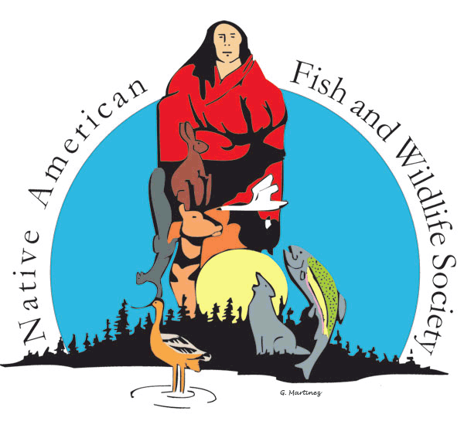
The Native American Fish and Wildlife Society will hold their annual conference in Spokane, Washington from October 4 – October 7, 2021 hosted by the Kalispel Tribe of Indians. The Conference will include workshops, panel discussions, contributed oral presentations, and posters.
We invite you to submit abstracts for prospective contributed oral or poster presentation on topics related to fisheries and wildlife ecology, management, conservation, education, or policy.
Abstracts submitted can be from:
- Research (in progress, proposals (with a focus on study design), completed)
- On-going projects, management practices and/or policy
- Case Studies (in progress, proposals, completed)
Contributed Oral Presentations will be scheduled for 20 minutes, which includes 15 minutes for the presentation and five minutes for questions.
Contributed Posters will be highlighted during our Student-Professional social event. Poster size should not exceed 48”x36”. Note: We highly advise that posters be printed before arriving at the conference, there may be no facilities to print at or near the conference, nor will posters be displayed electronically. STUDENTS ARE ENCOURAGED TO SUBMIT FOR THIS SESSION.
Instructions for Submitting Abstracts
Word document of abstract submissions should include title, authors, authors’ institution or department, authors’ email, abstract (must be under 300 words, and should include title, statement of objectives, brief description of methods, results, conclusions) and keywords.
The submission deadline is Saturday, July 31, 2021 at 10 pm MT. Abstracts will be evaluated and notice of decisions will be sent via email no later than Friday August 6, 2021. Please submit all abstracts to Ashley Carlisle, NAFWS Education Coordinator, acarlisle@nafws.org.
NAFWS does not pay registration fees, travel expenses or honoraria for presenters.
Students are encouraged to apply for the NAFWS National Conference Student Travel Scholarship, more information to come.

