Terrestrial Invasive Species Coordinator
Michigan Department of Natural Resources
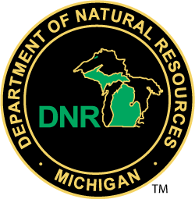
Location
Lansing, MI
Job Number: 7501-21-WILD-037
Job Description
This position assists in the coordination of the WLD’s Invasive Species program in collaboration with multiple Divisions and working with multiple departments: Environment, Great Lakes, and Energy (EGLE), Agriculture and Rural Development (MDARD) and Transportation (MDOT). This position provides and coordinates technical advice on invasive plants, mammals and birds and helps ensure priority actions are taken to understand and respond to invasive species threats. This position assists the departments to maintain an up-to-date Terrestrial Invasive Species (TIS) State Management Plan (SMP) and to implement the plan. This position also assists with the coordination of the TIS SMP with other statewide plans, including the Aquatic Invasive Species SMP and Michigan’s Wildlife Action Plan. This position attends various regional and national invasive species meetings and provides and coordinates technical expertise on invasive species to a variety of partner organizations through collaborative workgroups, state and federal invasive species grants, trainings, and meetings.
Skills we are looking for
- Ability and willingness to successfully engage a wide range of stakeholders, solicit input, and maintain relationships of respect and support.
- Ability to foster and maintain partnerships and coordinate management program activities with multiple agencies and partners.
- Ability to work well as part of a team, as well as lead effective teams.
- Understanding of the principles of invasive species management.
- Knowledge of information sources, contacts, and current developments in invasive species management.
- Ability to implement management programs that may be contentious or controversial.
- Open mind and an objective attitude.
- Ability to communicate in verbal and written formats with peers, decision makers. and the public.
- Ability to provide guidance to ensure proper use of invasive species funding and grant programs.
Required Education
Possession of a bachelor's degree in a physical, biological, or natural resource science, resource management, resource planning, engineering, or a related field.
Additional Requirements and Information
For a copy of the position description, click here

