|  |  |
| --- | --- |
| National Conference Agenda Sunday, May 11, 2025 | |
| 8:00 a.m. – 5:00 p.m.  Location: Cotton Wood | **NAFWS Board of Directors Meeting**  ***Coordinator:*** Mike LaVoie, Vice-President – NAFWS |
| Monday, May 12, 2025 | |
| 9:00 a.m. – 5:00 p.m.  Location: Hotel Lobby – Wind River Casino | **Exhibitors and Vendors Set-Up**  ***Coordinators:***Shailyn Wiechman, Wildlife Connectivity Coordinator – NAFWS  Andy Edwards, Grants Field Liaison – NAFWS |
| 9:00 a.m. – 5:00 p.m.  Location: Hotel Lobby – Wind River Casino | **Registration**  ***Coordinators:***Heidi McCann, Membership Engagement & Board Affairs Coordinator —NAFWS  Jennifer Bills, Financial Advisor – Management Partners |

|  |  |
| --- | --- |
| 9:00 a.m. – 10:00 a.m.  Location: Blue Sky 1 | Meeting: NAFWS Research/Publication Committee – Open to Committee Members only  *Coordinator:* Hannah Golden, Fish & Wildlife Biologist – NAFWS |
| 10:00 a.m. – 12:00 p.m.  Location: Blue Sky 2 | **Meeting:** Federal & State Relations Committee  ***Coordinator:*** Julie Thorstenson Ph.D., Executive Director – NAFWS |

|  |  |
| --- | --- |
| 9:00 a.m. – 5:00 p.m.  Location: Spring Mountain (Morning); Off-Site (Afternoon) | Workshop: Wildlife Health and Chronic Wasting Disease (CWD) Workshop  *Coordinators:* Shailyn Wiechman, Wildlife Connectivity Coordinator – NAFWS |
| 9:00 a.m. – 12:00 p.m.  Location: Cottonwood | **Workshop:** Diversifying Funding and Increasing Financial Resilience in Tribal F&W Programs  ***Coordinator:***Megan Hawkins, Director of Operations – NAFWS |
| 11:30 a.m. – 5:00 p.m.  Location: Off-Site | **Workshop**: Invasive Species Management Workshop  ***Coordinator:***Mitzi Reed, Invasive Species Coordinator – NAFWS  ***Instructions:*** *Meet at Wind River Hotel Lobby at 11:30 a.m., Please ensure you have lunch.* |
| 12:00 p.m. – 6:00 p.m.  Location: Off-site | **National CLEO Competition Shoot**  ***Coordinators:*** Robert Romero, CLEO & Hunter Education Consultant - NAFWS |
| 1:00 p.m. – 5:00 p.m.  Location: Cottonwood | **Workshop:** Adaptive Leadership Workshop  ***Coordinators:***  *Gina Jackson-Krusinski, Program Manager for Communications and Learning Development - Association of Fish & Wildlife Agencies*  *Mark Ohm, Regional Supervisor - South Dakota Game, Fish and Parks*  *Ashley Mueller, Education and Advancement Director – NAFWS* |
| 1:00 p.m. – 5:00 p.m.  Location: Spring Mountain | **Workshop:** Tribal Mapping  ***Coordinator:*** Emily Hagler, Tribal Mapping Analyst – NAFWS |
| 5:30 p.m. – 7:00 p.m.  Location: Spring Mountain | **Meeting:** NAFWS Great Plains Region Business Meeting  ***Coordinators:***Shaun Grassel, Ph.D. and Michael Thompson, GP Regional Directors – NAFWS  *Refreshments Will Be Served |
| 7:00 p.m. – 10:00 p.m.  Location:  Holiday Inn  Dome Area | **Professional Mixer** *(networking opportunity)*  Holiday Day Inn Riverton, 900 E Sunset Dr, Riverton, WY 82501  *Refreshments Will Be Served |

|  |  |
| --- | --- |
| Tuesday, May 13, 2025 | |
| 8:00 a.m. – 5:00 p.m.  Location: Hotel Lobby – Wind River Casino | **Registration**  *Coordinators:* Heidi McCann, Membership Engagement & Board Affairs Coordinator  Jennifer Bills, Financial Advisor – Management Partners |
| 8:00 a.m. – 5:00 p.m. | **Exhibitors and Vendors Set-Up**  ***Coordinators:***Shailyn Wiechman, Wildlife Connectivity Coordinator – NAFWS  Andy Edwards, Grants Field Liaison – NAFWS |
| General Session | |
| 9:00 a.m. – 9:45 a.m.  Location: Blue Sky | **Opening Ceremony**  Master of Ceremonies – Shaun Grassel, PhD – NAFWS Great Plains Region Director  Posting of the Colors – Conservation Law Enforcement Officers  Invocation – Sam Dresser, Northern Arapahoe  *Welcoming Remarks:*  NAFWS Executive Director – Julie Thorstenson, Ph.D.  NAFWS Vice-President, Southeast Region Director – Mike LaVoie  NAFWS Great Plains Region Director – Michael Thompson  Host Representative, Director of Wind River Fish & Game – Arthur Lawson |
| 9:45 a.m. – 10:00 a.m.  Location: Blue Sky | Conference Overview |
| 10:00 a.m. – 10:30 a.m.  Location: Blue Sky | **Keynote Address:** Leslie Shakespeare, Senior Leader Supporting Tribal Nations in the Rocky Mountain Region - BIA |
| 10:30 a.m. – 11:30 a.m.  Location: Blue Sky | **Presentation:** Wind River – Fisheries and Wildlife Management Overview  ***Presenter:*** Arthur Lawson, Director – Wind River Fish & Game |
| 11:30 a.m. – 1:00 p.m.  Location: Blue Sky | **LUNCH** (Provided) |
| 1:00 p.m. – 2:00 p.m.  Location: Blue Sky | **Presentation:** NAFWS National Office Update  ***Presenter:*** Julie Thorstenson Ph.D., Executive Director – NAFWS |
| 2:00 p.m. – 3:00 p.m.  Location: Blue Sky | **Panel Discussion:** Intertribal Organizations  ***Panelists:***  InterTribal Timber Council (ITC)– Jim Durglo, Fire Technical Specialist  National Congress of American Indians’ (NCAI) – Cynthia Harris, Director  Indian Nations Conservation Alliance (INCA) – Delane Atcitty, Executive Director  InterTribal Buffalo Council (ITBC) – Jason Baldes, Vice President  ***Moderator:*** Shaun Grassel, PhD, CEO Buffalo Nations Grasslands Alliance/NAFWS Great Plains Regional Director |
| 3:00 p.m. – 3:15 p.m. | **BREAK** |
| 3:15 p.m. – 4:00 p.m.  Location: Blue Sky | **Panel Discussion:** Co-Management and Co-Stewardship Success Stories  ***Panelists:*** Chairman Ryman LeBeau, Cheyenne River Sioux Tribe  Fawn Wagner, Wildlife Refuge Manager/Ecologist Dungeness/Protection Island  Marcel Bozas, Director Fish & Wildlife Department, Miccosukee Tribe of Indians of Florida  ***Moderator:*** Julie Thorstenson, Ph.D., Executive Director – NAFWS |
| 4:00 p.m. – 5:00 p.m.  Location: Blue Sky | **Presentation:** Federal Partner Updates  USDA APHIS – Denise Salvetti M.P.A., Program Analyst, Office of National Tribal Liaison  BIA – Diane Mann Klager, Natural Resource Officer  BLM – Casey Burns, Threatened and Endangered Species Ecologist  USFWS – Karen Cogswell, National Native American Program Advisor  ***Moderator:*** Michael Thompson, GP Region Director – NAFWS |
| ADJOURN 5:00 p.m. | |
| 6:30 p.m. – 8:00 p.m.  Location: Off-Site | **Traditional Feast**  Fort Washakie Powwow Grounds, 36 A Gaw Bombe Ln, Fort Washakie, WY 82514  **Limited Transportation Provided, Encourage Carpooling** |
| Wednesday, May 14, 2025 | |
| 8:00 a.m. – 5:00 p.m. | **Registration**  *Coordinators:* Heidi McCann, Membership Engagement & Board Affairs Coordinator —NAFWS  Jennifer Bills, Financial Advisor – Management Partners |

|  |  |  |  |  |
| --- | --- | --- | --- | --- |
| Concurrent Sessions I | | | | |
| Topic | **Fisheries Management** | **Wildlife Health** | **Sovereignty** | **Methods** |
| *Moderator:* | *Hope Roberts – AK Regional Director* | *Benjamin Simpson – NE Regional Director* | *Matt Gamble – SE Regional Director* | *Terry Metoxen – GL Regional Director* |
| Location: | Blue Sky Room 1 | Blue Sky Room 2 | Cotton Wood | Spring Mountain |
| 9:00 a.m. – 9:30 a.m. | Lake Whitefish (Coregonus clupeaformis) decline and possible senescence in Little Traverse Bay, Lake Michigan  *Kae Skubik, Little Traverse Bay Band of Odawa Indians* | Using non-invasive methods to detect small mammals: track plates, environmental DNA, and cameras  *Carol Chambers, Professor, Northern Arizona University* | Implications of environmental data collection on Tribal lands for Native Nations, Tribal Sovereignty and Indigenous Land Management in the Upper Missouri River Basin  *Paige Johnson, Native Resilience Data Fellow, Montana Climate Office* | Evaluating the efficacy of aversive conditioning of mountain lions with hounds  *Bart George, Wildlife Program Manager, Kalispel Tribe* |
| 9:30 a.m. – 10:00 a.m. | Native Fish Keepers  *Cindy Bras-Benson, Fisheries Specialist, Confederated Salish and Kootenai Tribes* | American black bear density and genetic diversity in Penobscot Nation, Maine, USA  *Jeff Stetz, Director of Science*  *Center for Wildlife Studies* | Landscapes of Land Return: Examining trends in land re-acquisitions by Indigenous communities in the United States  *McKalee Steen, Ph.D. Candidate, UC – Berkeley* | Black Bear Research on the Navajo Nation  *Deandra Jones, Ph.D. Student, University of Arizona* |
| 10:00 a.m. – 10:30 a.m. | Haich ik’tat’uu: Restoring and Reconnecting on the Siuslaw River Estuary on the Oregon Coast  *Jesse Beers, Cultural Stewardship Manager, Confederated Tribes of Coos, Lower Umpqua and Siuslaw Indians* | Chronic Wasting Disease Outbreak In the Wind River Basin: Historical Perspectives, Impacts, And Contributing Factors  *Tucker Russell, Graduate Research Assistant, University of Wyoming* | Conservation Easements and Bison Restoration: Exploring Opportunities, Challenges, and Alternatives  Alyson White Eagle, Fellow  Native American Rights Fund | Assessing Moose Distribution and Impacts of Winter Tick Using Remote Camera Surveys  *Nina Kappel, Graduate Student, University of Maine* |
| BREAK 10:30 a.m. – 11:00 a.m. | | | | |
| Topic | **Fisheries Management** | **Wildlife Management** | **Sovereignty** | **Methods** |
| *Moderator* | *Ted Lamebull – P Regional Director* | *Kai-T Blue-Sky – SW Regional Director* | *Shaun Grassel, PhD – GP Regional Director* | *Jason Mitchell - NE Regional Director* |
| *Location* | Blue Sky Room 1 | Blue Sky Room 2 | Cotton Wood | Spring Mountain |
| 11:00 a.m. – 11:30 a.m. | The Evolution of Supply Creek: Restoring Fish Habitat in the Hoopa Valley  *Ana Rubio, Stream Restoration Specialist,*  *Hoopa Valley Tribal Fisheries* | Female elk select habitat differently before, during, and after calving  *Daniel Bird, Graduate Student, University of Montana* | The McGirt Ruling  *Jay Harvey, Game Warden Supervisor, Choctaw Nation of Oklahoma* | Nature's Hidden Logbook: How eDNA can Inform Tribal Conservation and Land Management Decisions  *Julie Stanford, CEO, eDNA Explorer* |
| 11:30 a.m. – 12:00 p.m. | From Barriers to Solutions: Tribal Capacity Building for Fish Passage Restoration  *Madelynne Dey,Chickaloon Village Traditional Council* | Methods and Analysis of Endangered Bats on Cherokee Lands  *Jessica Nagel, Lead Wildlife Biologist, Eastern Band of Cherokee Indians* | Tribal Access to the Land and Water Conservation Fund  *Michael Spears, LWCF Tribal Access Author* | Braiding Indigenous Knowledge and Western Science in the Yellowstone Bison Species Status Assessment  *Ehakela Cummings, InterTribal Buffalo Council* |
| 12:00 p.m. – 2:00 p.m.  Location: Blue Sky | **NAFWS NATIONAL BUSINESS MEETING**  ***Coordinators:*** *Mike LaVoie, NAFWS Vice-President and Julie Thorstenson, PhD, NAFWS Executive Director*  *\*\*LUNCH PROVIDED\*\**  —SEE MEETING AGENDA— | | | |
| 2:30 p.m. – 5:00 p.m.  Location: Holiday Inn  Taggart’s Room 1 | **CLEO Training**  ***Coordinators:*** *Robert Romero, CLEO and Hunter Education Consultant*  Holiday Day Inn Riverton, 900 E Sunset Dr, Riverton, WY 82501 | | | |

|  |  |  |  |  |
| --- | --- | --- | --- | --- |
| Concurrent Sessions II | | | | |
| Topic | **Education & Outreach** | **Wildlife Management** | **Habitat Conservation** | **Methods** |
| *Moderator* | *Ashley Mueller, NAFWS Education Coordinator* | *Michael Thompson, GP Regional Director* | *Orville Huntington, AK Regional Director* | *Jason Mitchell, NE Regional Director* |
| Location | Blue Sky Room 1 | Blue Sky Room 2 | Cotton Wood | Spring Mountain |
| 2:00 p.m.– 2:30 p.m. | Descriptive Languages Can Guide Knowledge Revitalization to Reconnect Cherokees to their Aboriginal Landscape  *Caleb Hickman, Supervisory Fish & Wildlife Biologist, Eastern Band of Cherokee Indians* | Tribal Collaboration and the Olympic Cougar Project in Support of Habitat Connectivity Planning  *Kim Sager-Fradkin, Wildlife Program Manager, Lower Elwha Klallam Tribe* | Conservation Through Fire  *Sheldon Fletcher, C.W.A 319 & GIS Coordinator, Lower Brule Sioux Tribe* | Streamflow revival: A framework for monitoring and assessing the ecohydrological impacts of ongoing stream naturalization and land use conversion  *Cory Ott, Ph.D. Student, University of Wyoming* |
| 2:30 p.m.– 3:00 p.m. | The National Summer Youth Practicum: Highlights, Lessons Learned and Moving Forward  *Ashley Mueller, Education and Advancement Director, Native American Fish and Wildlife Society* | Toxicology Analysis in Moose Populations of the Ahtna Region (Alaska): Assessing Cadmium and Copper Impacts on Wildlife Health and Food Security  *Kelsey Stanbro, Ecologist, Ahtna Intertribal Resource Commission* | Bringing Back the Grass - Cultural, Ecological, and Environmental Benefits of Native Rivercane and Grasslands Restoration  *Marvin Bouknight, Wildlife & Habitat Program Manager, Catawba Nation* | Distributional Ecology of Medium and Large Mammals of the Baboquivari Mountain Range  *Kathryn Beard, Ecologist, Tohono O'odham Nation* |
| BREAK 3:00 p.m. – 3:30 p.m. | | | | |
| Topic | **Education & Outreach** | **Wildlife Management** | **Invasive Species** | **Plants** |
| *Moderator* | *Emily Hagler, NAFWS Mapping Analyst* | *Shailyn Wiechman, NAFWS Wildlife Connectivity Coordinator* | *Mitzi Reed, NAFWS Invasive Species Coordinator* | *Hannah Golden, NAFWS Fish & Wildlife Biologist* |
| Location | Blue Sky Room 1 | Blue Sky Room 2 | Cotton Wood | Spring Mountain |
| 3:30 p.m.– 4:00 p.m. | White Earth Natural Resources Youth Program  *Zoe Keezer, Environmental Coordinator, White Earth*  *Jason Clark,* *Parks & Recreation Manager*  *Ashley Zurn, Conservation Officer, White Earth* | Review of Wildlife Zoonoses and Game Meat Safety for Wildlife Biologists  *Tolani Francisco, Doctor of Veterinary Medicine, Native Healing LLC* | Pechanga's Goldspotted Oak Borer Efforts with the Community  *David Newman, Environmental Program Manager, Pechanga Tribal Government* | Ghvtlh-k'vsh shu'-srnelh-'i~ (Kelp Guardians) of California's North Coast  *Rosa Laucci, Marine Division Manager & Marine Biologist, Tolowa Dee-ni’ Nation* |
| 4:00 p.m.– 4:30 p.m. | Expanding Cherokee Youth Engagement in Fishing and Conservation  *Mike LaVoie, EBCI Natural Resources*  *Christopher Davis, Teacher, Cherokee Central Schools* | Navajo Bighorn Recovery Program Update  *Jessica Fort, Wildlife Biologist, Navajo Nation* | Tribal Pesticide Programs and Impacts to Tribal Resources  *Jasmine Courville, Pesticide Program Manager, Confederated Salish and Kootenai Tribes* | Understanding climate impacts on cone production and the need for comprehensive pinyon jay population monitoring in the Dinetah (Navajo Nation)  *Arantxa Curley, Post-Baccalaureate Student,*  *Northern Arizona University* |
| 4:30 p.m.– 5:00 p.m. | Seven Generations of Student Stewards  *Brandon Edwards, Natural Resources Technician, Forest County Potawatomi Land and Natural Resources* | Thirty Years of Wolves and Sovereignty: The Nez Perce Tribe’s Legacy and Future in Wolf Management  *Rosie Sanchez, Wildlife Carnivore Fellow, Nez Perce Tribe* | Ecological Concerns Of Feral Equidae  *Tolani Francisco, Doctor of Veterinary Medicine, Native Healing LLC* | Restoring the Land with Native Knowledge: Plant Restoration and the Asqinaq Cultural Ranger Program  *Angutekaraq Estelle Thomson, President, Native Village of Paimiut & Creator, Asqinaq Cultural Ranger Program* |
| ADJOURN 5:00 p.m. | | | | |
| 6:00 p.m. – 7:00 p.m.  Location: Holiday Inn  Dome Area | **Tribal Student and Professional Mixer and Poster Session**  ***Coordinator:*** Ashley Mueller, Education Coordinator – NAFWS  Holiday Day Inn Riverton, 900 E Sunset Dr, Riverton, WY 82501  *Refreshments will be served | | | |

|  |  |
| --- | --- |
| Thursday, May 15, 2025 | |
| 6:45 a.m. – 8:30 a.m.  Location:  Starting Line – | **5K Buffalo Stampede Fun Run & Walk**  ***Coordinators:***Thomas Hafen, Invasive Species Technician - NAFWS & Katie Schultz, Grants Field Liaison – NAFWS  *Instructions:*  *Pre-registrants receive race packet near the registration desk. On-site registration at conference registration desk.*  *Safety Briefing at 6:50 a.m. | Race Starts at 7:00 a.m.* |
| 9:30 a.m. – 5:00 p.m. | **Natural Resources Tours:**  ***Coordinators*:** Wilma Wagon, Wind River Fish & Game  ***Instructions:*** TBA Meet in Lobby at 9:20 a.m., Depart by 9:30 a.m.  ***Tours: See our website for full descriptions***  Wind River Canyon/ Boysen Peak- Fisheries, Tribal Outfitter, Scenic Views  Diversion Dam/ Bull Lake- Water Management, Invasive Species, and Fly Fishing  Red Rocks/ Dinwoody/ Washakie Reservoir- Ungulate Habitat, History, Petroglyphs  Crow Creek- **4wd required,** Migration Pathways, GPS Collar Retrieval, Geology, Sand Dune Visit |
| 6:30 p.m. – 9:30 p.m.  Location: Blue Sky | **BANQUET**  *Master of Ceremony: Mike LaVoie, NAFWS Vice-President, SE Regional Director – NAFWS*  *Retire the Colors*  *Invocation –* Ivan Posey, Eastern Shoshone  *National Award Announcements: Darren* Talayumptewa, *SW Regional Director - NAFWS*  National Tribal Student Poster Session Awards  Emerging Professional of the Year Award  Biologist of the Year Award  Chief Sealth Award  CLEO of the Year  National Conservation Officer Shoot Team Awards  *Great Plains Regional Award Announcements: Shaul Grassel, GP Regional Director - NAFWS*  *Silent Auction* –  Benjamin Simpson – NE Regional Director  Michael Thompson – GP Regional Director |

# **THANK YOU TO OUR SPONSORS:**

# **Platinum Sponsors**

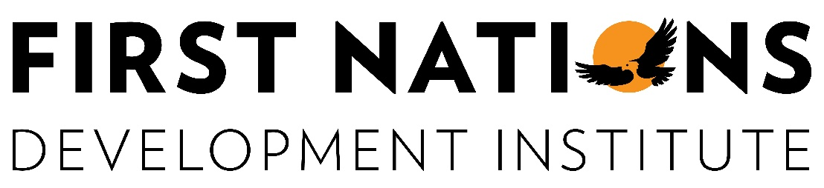 

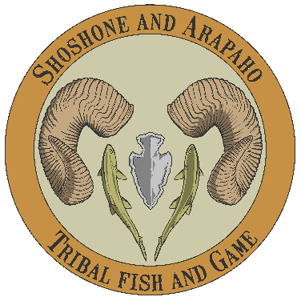 

**Gold Sponsors**

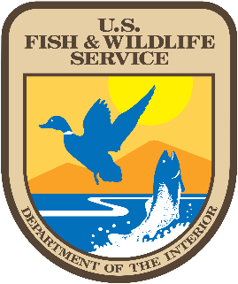 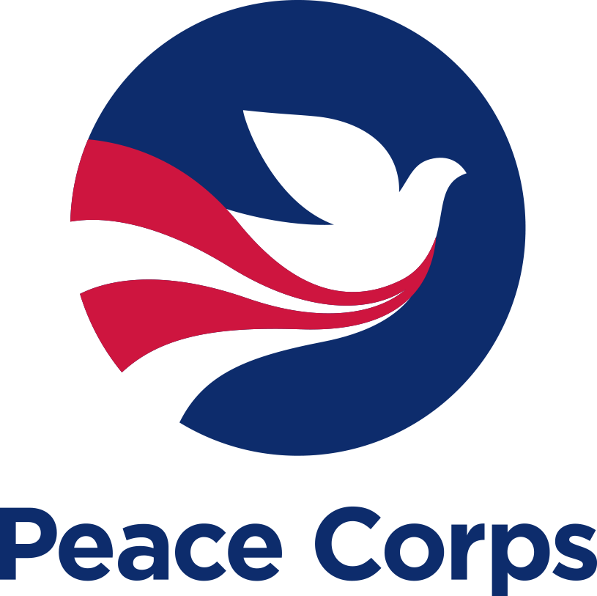

## **Silver Sponsors**

## **Bronze Sponsors**

